1. PROJECT TITLE:
Medical Equipment Management System.

2. PROJECT DESCRIPTION:
The Medical Equipment Management System is a console-based C program designed to manage medical equipment inventory efficiently. It allows users to add new equipment, display all equipment details, search for equipment by ID, update the quantity of existing equipment, and delete equipment records. This system helps hospitals and medical facilities maintain an organized record of their equipment, ensuring availability and proper tracking.

3. RESEARCH & BACKGROUND STUDY:
Managing medical equipment manually can lead to errors, misplaced items, and inefficient tracking. With the increasing number of medical devices in healthcare facilities, a computerized system is essential to maintain accurate records. The project is based on fundamental data structures in C, such as arrays and structures, to store and manipulate equipment data. The system uses basic file handling concepts and user input validation to ensure data integrity. This project builds on knowledge of C programming, including functions, loops, conditionals, and string handling.

4. SYSTEM DESIGN & IMPLEMENTATION;
4.1 System Required:
- Input new detail of equipment to add.
- Save the input equipment.
- Display all equipment.
- Search for the equipment by equipment id.
- Update or delete the equipment with the equipment id.

4.2 Algorithm:
- Start program.
- Show Menu:
    - Add Equipment
    - Display All Equipments
    - Search Equipment by ID
    - Update Equipment Quantity
    - Delete Equipment
    - Exit
- User enters choice.
- Switch based on choice:
  - If 1 → Call addEquipment()
  - If 2 → Call displayEquipments()
  - If 3 → Call searchEquipment()
  - If 4 → Call updateQuantity()
  - If 5 → Call deleteEquipment()
  - If 6 → Exit
  - Else → Invalid choice
- Repeat until choice = 6.
- Stop program.

4.3 FLOWCHART:

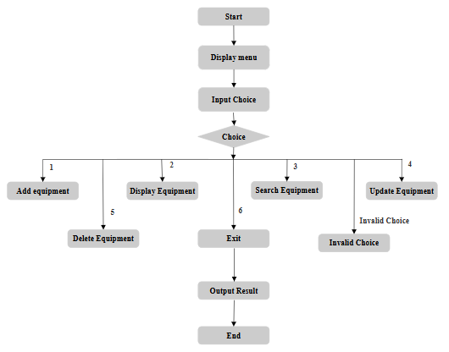

4.4 Program:
#include <stdio.h>
#include <string.h>

#define MAX_EQUIPMENTS 100

typedef struct {
int id;
char name[50];
int quantity;
char department[50];
} Equipment;

Equipment equipments[MAX_EQUIPMENTS];
int count = 0;

void addEquipment() {
if (count == MAX_EQUIPMENTS) {
printf("Storage full! Cannot add more equipment.\n");
return;
}
printf("Enter Equipment ID: ");
scanf("%d", &equipments[count].id);
getchar(); // consume newline
printf("Enter Equipment Name: ");
fgets(equipments[count].name, sizeof(equipments[count].name), stdin);
equipments[count].name[strcspn(equipments[count].name, "\n")] = 0; // remove newline
printf("Enter Quantity: ");
scanf("%d", &equipments[count].quantity);
getchar();
printf("Enter Department: ");
fgets(equipments[count].department, sizeof(equipments[count].department), stdin);
equipments[count].department[strcspn(equipments[count].department, "\n")] = 0;
count++;
printf("Equipment added successfully!\n");
}

void displayEquipments() {
if (count == 0) {
printf("No equipment to display.\n");
return;
}
printf("\n--- Medical Equipment List ---\n");
printf("%-5s %-20s %-10s %-20s\n", "ID", "Name", "Quantity", "Department");
for (int i = 0; i < count; i++) {
printf("%-5d %-20s %-10d %-20s\n", equipments[i].id, equipments[i].name, equipments[i].quantity, equipments[i].department);
}
}

void searchEquipment() {
int id;
printf("Enter Equipment ID to search: ");
scanf("%d", &id);
for (int i = 0; i < count; i++) {
if (equipments[i].id == id) {
printf("Equipment found:\n");
printf("ID: %d\nName: %s\nQuantity: %d\nDepartment: %s\n",
equipments[i].id, equipments[i].name, equipments[i].quantity, equipments[i].department);
return;
}
}
printf("Equipment with ID %d not found.\n", id);
}

void updateQuantity() {
int id, newQty;
printf("Enter Equipment ID to update quantity: ");
scanf("%d", &id);
for (int i = 0; i < count; i++) {
if (equipments[i].id == id) {
printf("Current quantity: %d\n", equipments[i].quantity);
printf("Enter new quantity: ");
scanf("%d", &newQty);
equipments[i].quantity = newQty;
printf("Quantity updated successfully.\n");
return;
}
}
printf("Equipment with ID %d not found.\n", id);
}

void deleteEquipment() {
int id, index = -1;
printf("Enter Equipment ID to delete: ");
scanf("%d", &id);
for (int i = 0; i < count; i++) {
if (equipments[i].id == id) {
index = i;
break;
}
}
if (index == -1) {
printf("Equipment with ID %d not found.\n", id);
return;
}
for (int i = index; i < count - 1; i++) {
equipments[i] = equipments[i + 1];
}
count--;
printf("Equipment deleted successfully.\n");
}

int main() {
int choice;
do {
printf("\n--- Medical Equipment Management System ---\n");
printf("1. Add Equipment\n");
printf("2. Display All Equipments\n");
printf("3. Search Equipment by ID\n");
printf("4. Update Equipment Quantity\n");
printf("5. Delete Equipment\n");
printf("6. Exit\n");
printf("Enter your choice: ");
scanf("%d", &choice);
getchar(); // consume newline

switch (choice) {
case 1:
addEquipment();
break;
case 2:
displayEquipments();
break;
case 3:
searchEquipment();
break;
case 4:
updateQuantity();
break;
case 5:
deleteEquipment();
break;
case 6:
printf("Exiting program.\n");
break;
default:
printf("Invalid choice! Please try again.\n");
}
} while (choice != 6);

return 0;
}

4.5 OUTPUT:
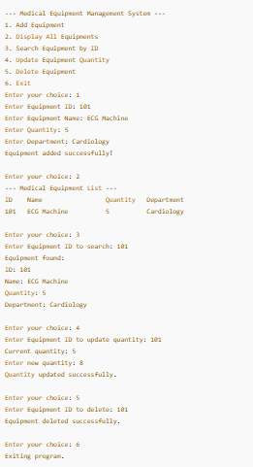

5. TESTING AND RESULTS:
5.1 TESTING:
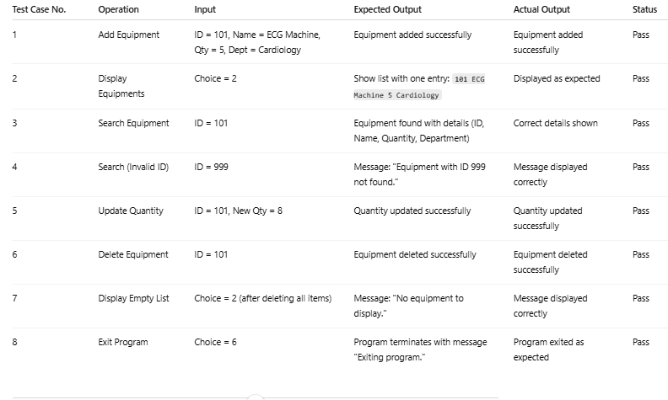

5.2 RESULTS:
The Medical Equipment Management System was successfully implemented in the C programming language. The program provides a menu-driven interface for managing medical equipment in a healthcare setup.
The following functionalities were tested and worked as expected:
- Add Equipment → New equipment records were successfully added.
- Display Equipments → All stored equipment records were displayed in a tabular format.
- Search by ID → Equipment could be searched using a unique ID, and correct details were retrieved.
- Update Quantity → The stock quantity of existing equipment was updated correctly.
- Delete Equipment → Equipment records were deleted successfully, and the list was updated.
- Exit → Program terminated gracefully when the user chose the exit option.

6. CONCLUSION:
The Medical Equipment Management System was successfully implemented in C to manage hospital equipment efficiently. It allows adding, displaying, searching, updating, and deleting records through a simple menu-driven interface. The system works as expected, reduces manual effort, and can be further enhanced with file storage, database integration, and a graphical interface.

